**Experiment -8**

**Aim:**

1. Design an inverting and non-inverting amplifier using opamp using F/B network
2. Determine bandwidth of amplifier using ac analysis
3. Evaluate the open loop gain. Loop gain and vlose loop gain of both the amplifier (VFB/VTEST) and do ac analysis
4. Comment on the stability of the feedback amplifier

**Apparatus used:** LTSpice software

**Theory:**

An **Operational Amplifier**, or op-amp for short, is fundamentally a voltage amplifying device designed to be used with external feedback components such as resistors and capacitors between its output and input terminals

Op-amp Parameter and Idealised Characteristic

* Open Loop Gain, (Avo): Infinite
* Input impedance, (ZIN): Infinite
* Output impedance, (ZOUT): Zero
* Bandwidth, (BW): Infinite
* Offset Voltage, (VIO): Zero

**Inverting amplifier:**

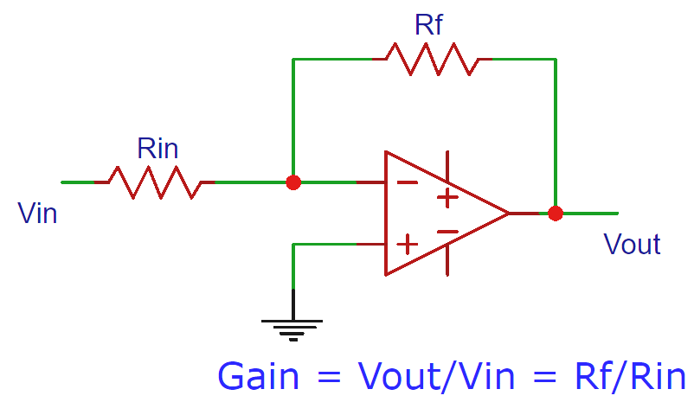

**Non Inverting amplifier:**

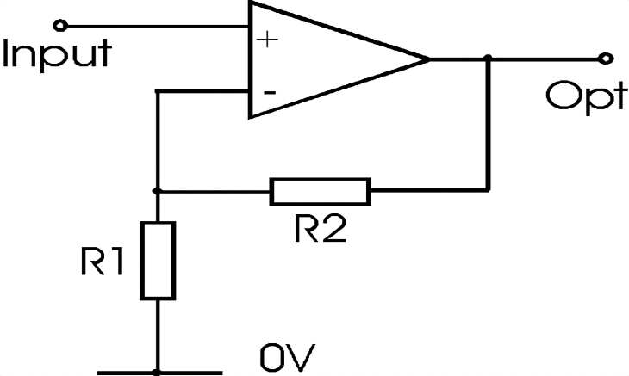

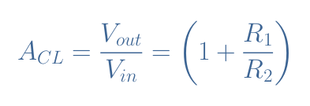

**Inverting**